**EXAMPLE 1 :**

*Problem Statement*

Calculate area of a rectangle

*Analysis (IPO)*

Input : length, width

Process : area = length X width

Output : area

*Algorithm (Pseudocode & Flowchart)*

1. *Flowchart*

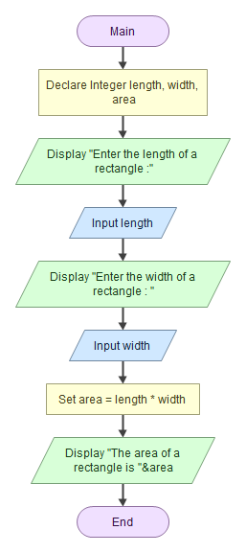

1. Pseudocode

Start/begin

Declare Integer length, width, area

prompt "Enter the length of a rectangle :"

read length

prompt "Enter the width of a rectangle : "

read width

calculate area = length * width

display "The area of a rectangle is ", area

Finish/end

***Sample of output :***

*Sample 1*

Enter the length of a rectangle :

4

Enter the width of a rectangle :

5

The area of a rectangle is 20

*Sample 2*

Enter the length of a rectangle :

10

Enter the width of a rectangle :

20

The area of a rectangle is 200

**EXAMPLE 2 :**

Problem Statements :

Your coding needs to enter the name of the item, quantity that you want to purchase and price of the item/unit. You need to calculate the item price and given the GST rate is 3.5%. Calculate the total price of the item together with the GST charges. Display the item name, quantity purchased, price per item, total price before GST, GST charges and total price with GST.

*Analysis (IPO)*

Input : itemName, quantity, priceperunit

Process : calculate totalprice = quantity X priceperunit

gstTax = totalprice X 0.035

totalwithGST = totalprice + gstTax

Output : itemName, quantity, priceperunit, totalprice, gstTax, totalwithGST

*Algorithm (pseudocode and flowchart)*

*Flowchart*

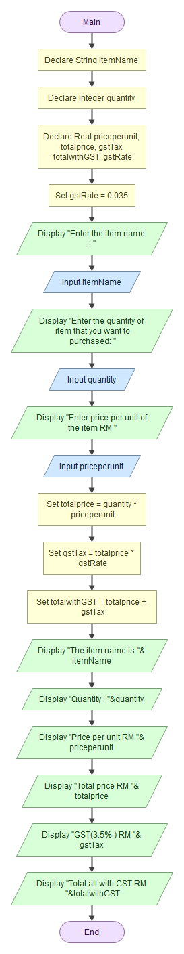

*Pseudocode*

start

Declare String itemName

Declare Integer quantity

Declare Real priceperunit, totalprice, gstTax, totalwithGST, gstRate

Initial/set gstRate = 0.035

prompt "Enter the item name : "

read itemName

prompt "Enter the quantity of item that you want to purchased: "

read quantity

prompt prompt "Enter price per unit of the item RM "

read priceperunit

calculate totalprice = quantity * priceperunit

calculate gstTax = totalprice * gstRate

calculate totalwithGST = totalprice + gstTax

Display "The item name is ", itemName

Display "Quantity : ", quantity

Display "Price per unit RM ", priceperunit

Display "Total price RM ", totalprice

Display "GST(3.5% ) RM ", gstTax

Display "Total all with GST RM ", totalwithGST

Finish

Sample output

*Sample 1*

Enter the item name :

pen drive

Enter the quantity of item that you want to purchased:

2

Enter price per unit of the item RM

35

The item name is pen drive

Quantity : 2

Price per unit RM 35

Total price RM 70

GST(3.5% ) RM 2.45

Total all with GST RM 72.45

*sample 2:*

Enter the item name :

cd rom

Enter the quantity of item that you want to purchased:

10

Enter price per unit of the item RM

0.50

The item name is cd rom

Quantity : 10

Price per unit RM 0.5

Total price RM 5

GST(3.5% ) RM 0.175

Total all with GST RM 5.175

**Example 3 (Group B):**

Write a complete documentation such as the IPO, pseudocode, flowchart and sample of output for the following problem statements. You need to develop one simple application to obtain three integer numbers from the user and calculate the summation & multiplication of three numbers.

Display the numbers that user has entered and the result of summation & multiplication



*IPO*

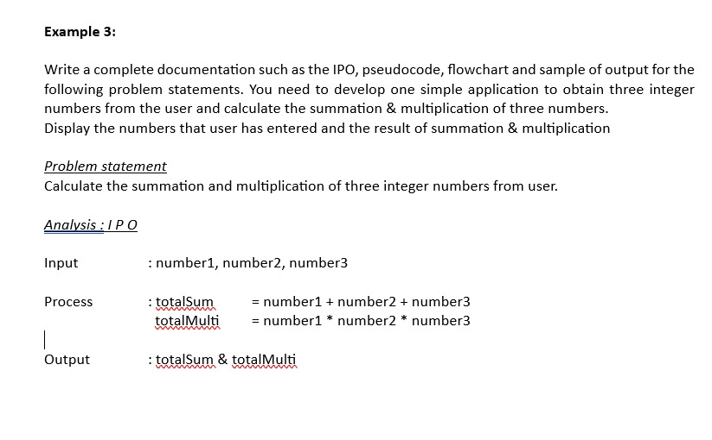



*Flowchart*

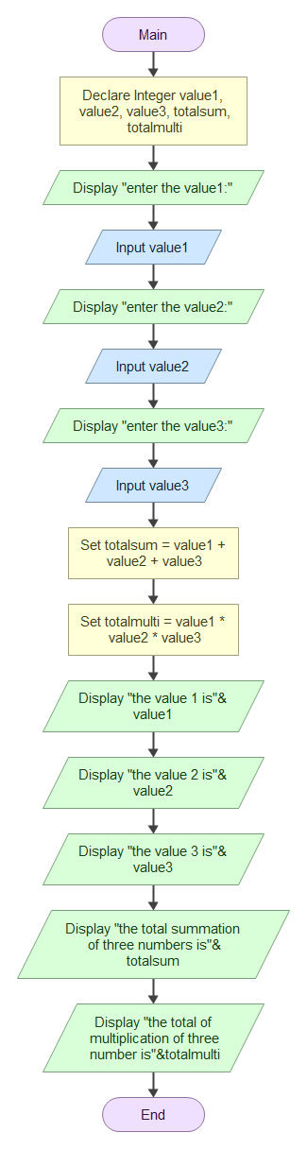



*Pseudocode*

Start

Declare Integer Value1, Value2, Value3, Summation, Multiplication

Prompt “Enter 1st number : ”

Read Value1

Prompt “Enter 2nd number :”

Read Value2

Prompt “Enter 3rd number :”

Read Value3

Calculate Summation = Value1 + Value2 + Value3

Calculate Multiplication = Value1 * Value2 * Value3

Display “You entered the numbers : ” , Value1 , Value2 , Value3

Display “Summation of the 3 numbers is ” , Summation

Display “Multiplication of the 3 numbers is ” , Multiplication

End

*Sample of output*

Sample 1

Enter 1st number : 2

Enter 2nd number : 3

Enter 3rd number: 4

You entered the numbers : 2, 3, 4

Summation of the 3 numbers is 9

Multiplication of the 3 numbers is 24

Sample 2

Enter 1st number : 9

Enter 2nd number : 8

Enter 3rd number: 7

You entered the numbers : 9, 8, 7

Summation of the 3 numbers is 24

Multiplication of the 3 numbers is 504

**Example 3 (Group A):**

Write a complete documentation such as the IPO, pseudocode, flowchart and sample of output for the following problem statements. You need to develop one simple application to obtain three integer numbers from the user and calculate the summation & multiplication of three numbers.



Display the numbers that user has entered and the result of summation & multiplication



*IPO*



Input: number1, number2, number3  
Process: Calculate sum = number1 + number2 + number3  
 Calculate multiplication = number1 * number2 * number3



Output: number1, number2, number3, sum, multiplication



Flowchart



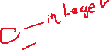

Pseudocode



Start



Declare Real number1, number2, number3, sum, multiplication



Prompt "Enter the first number: "



Read number1

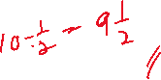

Prompt "Enter the second number: "



Read number2



Prompt "Enter the third number: "



Read number3



Calculate sum = number1 + number2 + number3



Calculate multiplication = number1 * number2 * number3



Display "Your first number is: ", number1



Display "Your second number is: ", number2



Display "Your third number is: ", number3



Display "The sum of the three number is: ", sum



Display "The multiplication of the three number is: ", multiplication



End



*Sample of Output (1)*

Enter the first number:

1



Enter the second number:

2



Enter the third number:

3



Your first number is: 1



Your second number is: 2



Your third number is: 3



The sum of the three number is: 6



The multiplication of the three number is: 6



*Sample of Output (2)*

Enter the first number:

10



Enter the second number:

12



Enter the third number:

6



Your first number is: 10



Your second number is: 12

Your third number is: 6



The sum of the three number is: 28



The multiplication of the three number is: 720



**Example 4:**



Write the analysis, pseudo code and draw the flowchart that will calculate the simple interest using the formula I = PTR/100 where P is the principal, T is the time and R is the Rate. P, T and R will be entered by user. Then, develop a complete program based from the analysis. You will have to compile and execute the program to show how the program works.



*IPO*



input : principle, time, interest_rate



process : interest = principle x time x interest_rate / 100

total_all_loan = principle + interest

Output : interest, total_all_loan



*Flowchart*



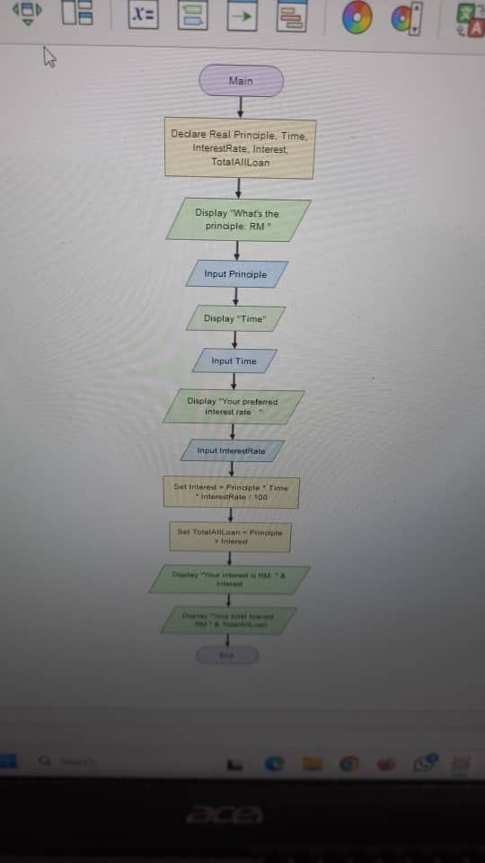



*Pseudocode*

Start

Declare Real principle, time, iRate, interest, total

Prompt "Enter principle: RM"

read principle

Prompt "Enter time of loan: "

Read time

Prompt "Enter your bank's interest rate"

Read iRate

Calculate interest = ( principle * time * rate ) / 100

Calculate total = principle + interest

Display "Your total interest: RM"&interest

Display "Your total loan: RM"&total

End

*Sample of output*

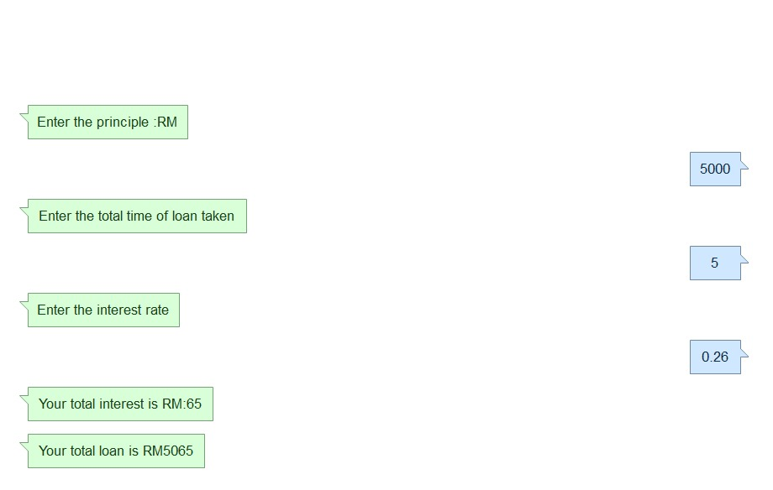

**Example 5:**

Four workers were responsible to pluck oranges. The owner of the orange farm will be given 40% of the oranges. The workers share equally the balance of the oranges. Write the analysis, pseudo code, draw the flowchart and develop a program that accepts input for the amount of oranges that were plucked. You are also required to calculate and print amount of oranges that were received by the owner and each of the workers. Sample of the output is as follows:

**Enter amount of oranges = 100**

**Total amount of oranges entered = 100**

**Total amount of oranges for owner (40%) = 40**

**Balance of oranges = 60**

**Total amount of oranges for each worker = 15**

*IPO*

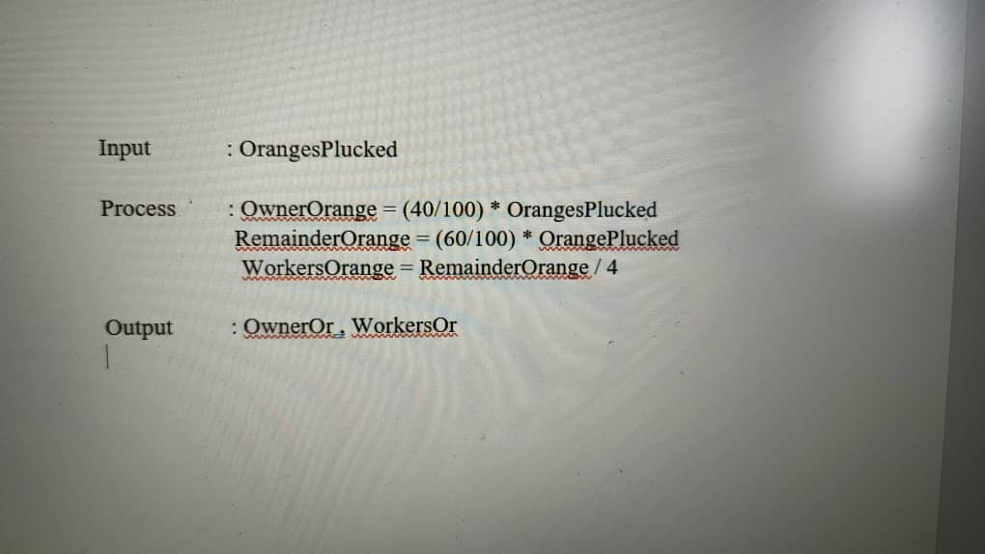

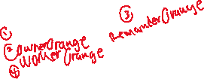

*Flowchart*

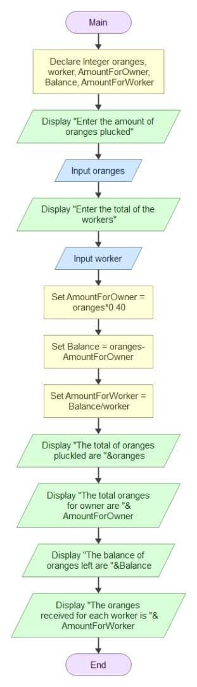



*Pseudocode*

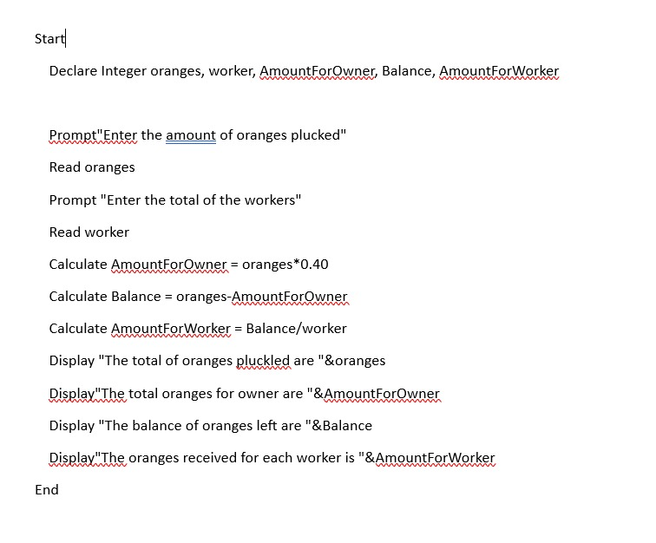



*Sample of output*

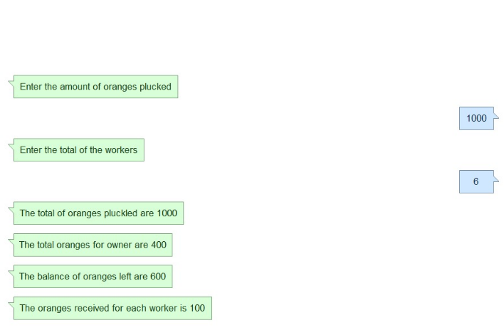



**Enter the amount of oranges plucked**

**1000**

**Enter the total of the workers**

**6**

**The total of oranges pluckled are 1000**

**The total oranges for owner are 400**

**The balance of oranges left are 600**

**The oranges received for each worker is 100**

**Example 6:**

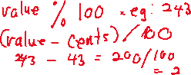

Write the analysis, pseudo code, draw the flowchart and show sample of output that will compute the value of the coins in a purse in Ringgit Malaysia and in cents. For example, if value is 243, then the total value will be 2 Ringgit Malaysia and 43 cents. Compile and execute your program.



IPO :



Input : value

Process : ringgit = value / 100

cents = value – ringgit x 100

Output : ringgit , cents

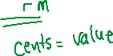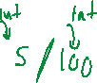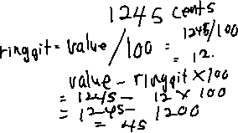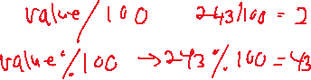

**Flowchart**

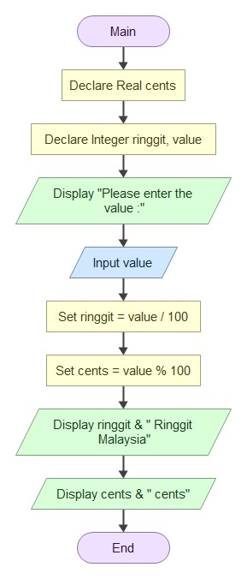



**Pseudocode**

**Start**

**Declare integer value, ringgit, cents**

**Prompt "enter the value number"**

**Read value**

**Calculate ringgit = value / 100**

**Calculate cents = value - ringgit * 100**

**Display "the amount of ringgit is RM "&ringgit**

**Display "the amount of cents is "&cents**

**End**

**Sample Output :**

**enter the value number**

**243**

**the amount of ringgit is RM 2**

**the amount of cents is 43**

**Example 7:**

The formula to calculate the velocity of item that traveling from one place (p1) to another place (p2) between (t1) and (t2) time is given as below. Write the analysis, pseudo code and draw the flowchart, which will calculate the velocity. The formula is: V = (p1-p2) / (t1-t2). After the analysis is completed, develop the complete program. Then, compile and execute the program to show how the program works.

*IPO*

Input : t1, t2, t1, t2  
Process : V = (p1 – p2)/(t1-t2)  
Output : V

*Flowchart*

*Pseudocode:*  
Start

Declare Real t1, t2, p1, p2, v

Prompt "Enter position 1: "

Read p1

Prompt "Enter position 2: "

Read p2

Prompt "Enter the start time: "

Read t1

Prompt "Enter the end time: "

Read t2

Calculate V = p1 - p2 / t1 - t2

Display "The velocity, V is ", V

End

*Sample of Output (1):*

Enter position 1:

0

Enter position 2:

100

Enter the start time:

0

Enter the end time:

50

The velocity, V is 2

*Sample of Output (2):*  
Enter position 1:

10

Enter position 2:

50

Enter the start time:

2

Enter the end time:

12

The velocity, V is 4